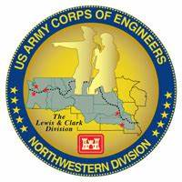
Columbia River System (CRS) Fish Facility Design Review Work Group (FFDRWG)

USACE, Portland District (NWP) and Walla Walla District (NWW)
  - February 2024 Written Updates
Meeting Date: February 1, 2024, 09:00-12:00
Webex: https://usace1.webex.com/join/jacob.macdonald
Join by phone (audio only, no Webex): (844) 800-2712 | Access Code: 1995 00 9820
FFDRWG Meeting Files:
https://pweb.crohms.org/tmt/documents/FPOM/2010/FFDRWG/FFDRWG.html

FFDRWG contact list
BPA
Scott Bettin
Christine Petersen
Leah Sullivan
Ben Hausmann
Carolina Andes
Josh Ashline
Tammy Mackey
NOAA
Blane Bellerud
Gabriel Brooks
Trevor Conder
Claire McGrath
Kelsey Swieca
Chris Magel
Kinsey Frick
Dana Bethea
USFWS
Dave Swank
Shelby Fowler
Joe Skalicky
States
Erick Van Dyke (ODFW)
Ben Clemens (ODFW)
Charles Morrill (WDFW)
Jonathan Ebel (IDFG)
CRITFC/Tribes
Tom Lorz (CRITFC)
Laurie Porter (CRITFC)
Greg Silver (CRITFC)
Casey Baldwin (CTCR)
Michael Karnosh (CTGR)
Lawrence Schwabe (CTGR)
Torey Wakeland (CTGR)
Aaron Jackson (CTUIR)
Ralph Lampman (YN)
Tod Sween (NPT)
Lyman Jim (CTWS)
NPCC
Kris Homel
FPC
Erin Cooper
Noah Campbell
PSMFC
Alan Brower
Darren Chase
Roger Clark
Mark Leonard
Scott Livingston
Nicole Tancreto
Don Warf
CENWD
Doug Baus
Tim Dykstra
Dan Feil
Cindy Studebaker
Lisa Wright
Sean Tackley
Ian Chane
CENWP-PM
Ida Royer
Erin Kovalchuk
Mark Bierman
Brad Eppard
Nathan McClain
Jake Macdonald
Jon Rerecich
David Trachtenbarg
Scott Fielding
Rebecca Cates
CENWP-OD
Andrew Derugin
Jeanette Flemmer
Tucker Gossett
Jaselyn Owens
Bob Cordie
Jeffrey Randall
Aaron Young
Eric Grosvenor
Michael Lotspeich
Laura Rickets
Noah Campbell
Robert Wertheimer
Patricia Madson
Darren Gallion
Kyle Tidwell
CENWP-ENC
Adam Jones
Adam White
Brandt Bannister
Shari Dunlop
Chris Motti
Steve Schlenker
Max Wilson-Fey
Collin Porter
Dan Penn
Aaron Litzenberg
Mehdi Roshani
Cole Marfise
CENWW-PM
Chuck Barnes
Steve Juhnke
Steve Sipe
Ricardo Walker
Brad Trumbo
Liana Aker
Michael Erickson
CENWW-OD
Chris Peery
Denise Griffith
Elizabeth Holdren
Ken Fone
Bobby Johnson
Deb Snyder
CENWW-ENC
Jon Renholds
Sean Milligan
Ryan Pestes
Travis Foster
John Lomeland
Ryan Laughery

Action items from previous meetings
- Macdonald: NWP BON2 FGE will be removed from future FFDRWG agendas.
  - Completed.
- Macdonald: Jake will schedule a tour of The Dalles LPS in conjunction with the AFEP annual review on the morning of January 23rd.
  - Not completed. Will attempt to reschedule in February-March, after water-up.
- Macdonald: Jake will schedule a Webex call for interested FFDRWG and FPOM participants with relevant experience to help CRITFC/Tribes develop a video monitoring plan for when the floating lamprey collector prototype is being tested at The Dalles Dam.
  - Not completed yet

NWP Topics for FFDRWG Update/Review/Coordination

NWP BON Spillway rock mitigation – Captain Adams (PM), Adam Jones (TL), Rebecca Cates (FFDRWG)
- CFD modeling is completed for the barriers and their deadweight anchor requirements, design will remain the same. Working toward 60% DQC and FFDRWG review.

NWP BON1 PIT Detection – Mark Bierman (PM), Jeanette Flemmer (FFDRWG)
- Design work is underway. Final, approved design expected in September of 2024.
- FY24 design work is funded. FY25 budget for installation support and EDC phase is being developed.

NWP TDA Backup AWS debris management – Erin Kovalchuk (PM), Mehdi Roshani (TL), Jon Rerecich (FFDRWG)
- Waiting for funding and a new PM assignment to start DDR phase.

NWP BON1 adult lamprey passage improvements – Erin Kovalchuk (PM), Adam White (TL), Jake Macdonald (FFDRWG)
- Construction progressing on schedule. No issues to report.

NWP BON2 control section redesign – Erin Kovalchuk (PM), Adam White (TL), Jake Macdonald (FFDRWG)
- 90% Plans and DDR are available on FFDRWG website.
- Working toward construction contract award summer 2024 for winter 2024-2025 construction.

NWP TDA adult lamprey passage improvements – Erin Kovalchuk (PM), Adam White (TL), Jake Macdonald (FFDRWG)
- Construction progressing on schedule. No issues to report.

NWP JDA adult lamprey passage improvements – Erin Kovalchuk (PM), Adam White (TL), Jake Macdonald (FFDRWG)
- South entrance weir cap fabrication is complete.
- Waiting on new bushings to arrive (~2 weeks out) before we can reweld the guide wheels and install the weir for fish passage season.

NWP BON2 floating adult lamprey trap for tribal translocation (*partner project; not a USACE design) – Ralph Lampman (TL), Jake Macdonald (FFDRWG)
- CRITFC/Tribes are designing an anchoring system for The Dalles East Fish Ladder entrance area that doesn’t have any lines in the water.
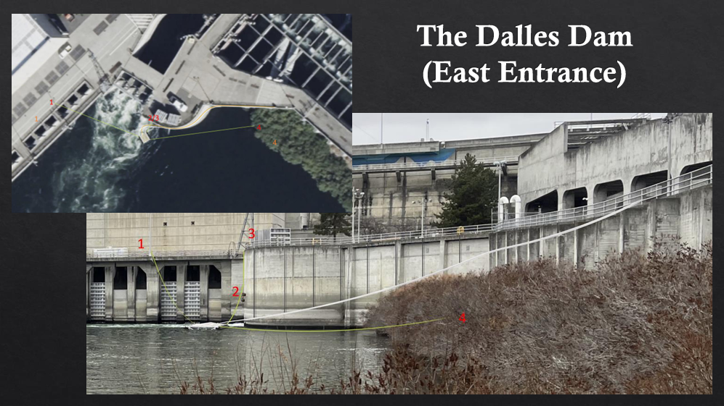
Conceptualized anchoring system for a floating adult lamprey collector prototype that will be evaluated at The Dalles Dam in 2024. Presented by Ralph Lampman at the AFEP annual review. Full slide decks for this and other AFEP presentations are available here: https://pweb.crohms.org/tmt/documents/FPOM/2010/SRWG/AFEP%20Presentations/.
- Jake will schedule a Webex call for interested FFDRWG and FPOM participants with relevant experience to help CRITFC/Tribes develop a video monitoring plan for when the floating lamprey collector prototype is being tested at The Dalles Dam.

NWW Topics for FFDRWG Update/Review/Coordination

NWW IHR Turbine Unit Cooling Water Exclusion Structure- Steve Juhnke (PM), Liana Aker (Bio)
- Next available unit for installation is unit 6 in October 2024. Unit 1 was originally targeted but the turbine is being replaced and won’t be online until 2026.
- Survey crew did a laser scan of scroll case walls in November.
- Final review set (DDR & Plans) was emailed to FFDRWG by Steve Juhnke on 29-Jan. The drawing set is only 8 pages so it should be a quick review.
- We are on a short timeline, so please provide comments back to Steve by COB 8-Feb.

NWW MNA Turbine Replacement Design – Jean Desjarlais (PM), Jon Renholds (TL)
- No update currently.

NWW LGA Adult Ladder Cooling Chimney Flap Gate- Steve Juhnke (PM), Chuck Barnes (Bio)
- Being fabricated in-house, will be done by the end of Feb.

NWW LLA Adult Ladder Turn Pool Gate- Greg Linklater (PM), Chuck Barnes (Bio)
- Design has been finalized. Installation to occur in 2025.

NWW Lower Granite cooling pumps – (PM yet to be determined)
- No update currently.

NWW MCN Avian deterrence – Steve Juhnke (PM)
- A/E contractor to perform an alternatives analysis in 2024. Earliest possible construction of a chosen alternative would be 2025.

NWW MNA PIT Detection – Steve Juhnke (PM)
- NWW staff to perform an alternatives evaluation in 2024.
- PDT will include staff from NOAA Science Center and evaluate alternatives presented by Gabriel Brooks (NOAA) at the AFEP annual review. Gabriel’s presentation is available here: https://pweb.crohms.org/tmt/documents/FPOM/2010/SRWG/AFEP%20Presentations/
- PDT will review and consider the language in the new Stay Agreement specific to the MNA spillway early in the process, per recommendation from Trevor Conder at the January FFDRWG.

NWW John Day Dam and Snake River Ladder Cooling – Steve Juhnke (PM)
- McNary, Lower Monumental, Ice Harbor, and John Day
- A/E contractor to perform an alternatives analysis in 2024. Earliest possible construction of a chosen alternative would be 2025.

NWW MNA Draft Tube Slot Filler – Jean Desjarlais (PM), Jon Renholds (TL), Chuck Barnes (Bio)
- Had to add a cross-member, will redistribute 60% design package for review.

Upcoming meetings and field trips

FFDRWG and FPOM will not be combined again in the future.

Next regularly scheduled NWW/NWP FFDRWG meeting – Thursday, March 7th @ 09:00
  - Considering an in-person FFDRWG at The Dalles Dam so we can tour the East Fish Ladder while we’re there. Send Jake your thoughts if you have them.
  - Send suggestions for agenda items to Jake Macdonald and Chuck Barnes

Field trips to inspect dewatered fishways during in-water work window (December-January)
  - Bonneville Bradford Island Ladder – Did it. 12/20/2023.
  - The Dalles East Fish Ladder – Jake tried to schedule in conjunction with AFEP annual review on 1/23 but cancelled due to weather. Will attempt to reschedule in February-March, after water-up.
  - Lower Granite Dam and fish ladder – Liana Aker tried for January 16th but cancelled due to weather. Will attempt to reschedule. Contact Liana if you would like to attend.
  - Ice Harbor South ladder (morning) and McNary South ladder (afternoon) - Liana Aker tried for January 17th but cancelled due to weather. Will attempt to reschedule. Contact Liana if you would like to attend.
  - Send suggestions for additional field trips to Jake Macdonald, Chuck Barnes, and Liana Aker

Field trip for FFDRWG and Corps-Tribal Lamprey Work Group to see floating lamprey collector in operation.
  - Partial day, In-person site visit to Tanner Creek hatchery – CRITFC/Tribes will schedule when they’re ready (April-May)
  - Partial day, In-person site visit to The Dalles Dam – Jake/CRITFC/Tribes will schedule when ready, later in the 2024 fish passage season.

Field trip for FFDRWG and Corps-Tribal Lamprey Work Group to see JDA adult lamprey passage improvements in operation.
  - Partial day, In-person site visit to John Day Dam – Jake will schedule during the peak of the 2024 fish passage season.

